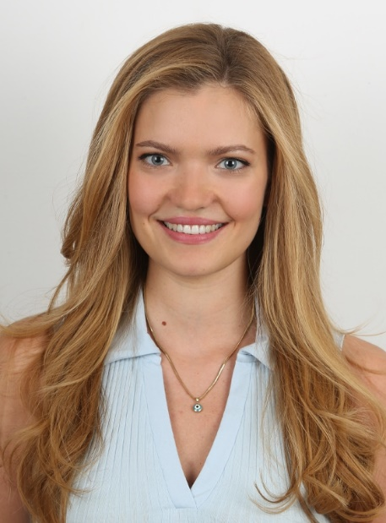

**NAME SURNAME**

Teacher

CONTACT İNFORMATİON

Telephone: 111-111-1111

E-Mail:xxxxxxxx@xxx.com

Address:

PERSONAL İNFORMATİON

Birthplace:

Date of Birth:

Marital Status:

Driving Licence:

Military Service:

LANGUAGE

English:

Spanish

HOBBİES



ABOUT ME

I am an elementarys school teacher with 10 years of experience, known form y passion for children’s learning processes. I graduated from (University Name) with a degree in (Field)i and I hold a pedagogical formation certificate. By adopting a student- centered approach, I respect each individual’s unique learning style and shape my lessons accordingly.

EDUCATİON

20XX-20XX xxxxxxxx University /Field

20XX-20XX xxxxxxxx High School

WORK EXPERİENCE

20XX-20XX Workplace/ Position

duties and responsibilities:

20XX-20XX Workplace / Position

duties and responsibilities:

20XX-20XX Workplace / Position

duties and responsibilities:

|  |  |  |  |
| --- | --- | --- | --- |
| SEMİNARS and COURSES | | COMPUTER | |
| 20XX | Course Name | MS Word |  |
| 20XX | Seminar Name | MS Excel |  |
| 20XX | Course Name | Other |  |
| 20XX | Seminar Name | Other |  |
| 20XX | Course Name |  |  |

REFERANCE

Name SORNAME- *Field Of Expertise* -Number

Name SORNAME - *Field Of Expertise* - Number

Name SORNAME - *Field Of Expertise* -Number